14th International Master Class for piano
Peter Feuchtwanger

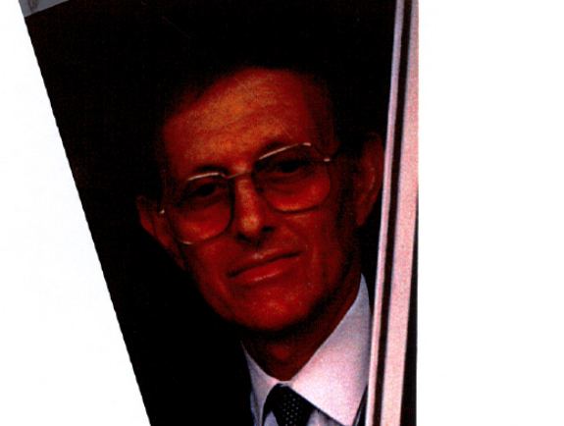

Peter Feuchtwanger was born in Munich, Germany. He studied piano with Gerti Rainer (a pupil of Emil von Sauer), Max Egger, Edwin Fischer and Walter Gieseking, composition with Hans Heimler (a pupil of Alban Berg, Heinrich Schenker and Felix Weingartner) and Lennox Berkeley and also Indian and Arabic music and philosophy with Nazir Jairazbhoy and Dr. Arnold Bake. His encounter with the Rumanian pianist, Clara Haskil was the most decisive musical influence in his life. He has also researched into Belcanto, the technique used in the golden age of singing. Peter Feuchtwanger is a member of the jury of many international piano compositions and Vice President of EPTA UK (European Piano Teachers’Association). He is Professor and Vice president of the Internationaler Akademie für musikalische Bildung e.V. and has been a visiting Professor at the Mozarteum in Salzburg. He has been giving master classes throughout the world since 1967. Peter Feuchtwanger lives and works in London.

“ He has great experience as a teacher and to work with him has always been a great experience, his advice always helpful, never arbitrary and of an incredible high standard…”
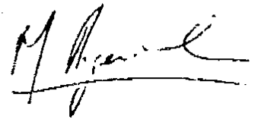
Martha Argerich
“As a teacher he is extraordinary. He seems to know immediately what is wrong with a pianist and he explains so easily the reason - what is wrong and what is right - and puts the pupil at ease and draws out the best. In fact I do not know anyone like Mr. Feuchtwanger who can so quickly lead the artist in the right direction.”

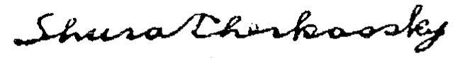
Shura Cherkassky

"Peter Feuchtwanger is a great musician and an important teacher."

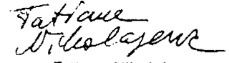

Tatjana Nikolajewa

"Peter Feuchtwanger´s work at the piano and on music is without equal. Before I came to know this way of working, I would not have believed that it was possible to teach at such a high level. The work is without ´method´, other than perhaps this: every student is developed from within himself. Peter Feuchtwanger is a unique phenomenon. He has a deep knowledge of inner connections. To recommend him for a particular task is an almost grotesque idea: I know of no pianist who could not profit from Feuchtwanger´s ideas."

Günter Reinhold, former Professor of Piano in Karlsruhe

After having known and worked several years with Peter Feuchtwanger, there is no doubt that he belongs to the very rare outstanding musical personalities. He has achieved a total equilibrium between knowledge and musical instinct, that is to say, he provides all that is necessary to bring music alive.

It should be added, that having himself a most natural and logical piano technique, and after a long experience of teaching, he can guide his pupils very surely in solving their difficulties in the simplest possible way. He therefore carries on a tradition, although most individually, of an almost forgotten art of piano playing.”
Dinorah Varsi

Waldkirch is situated 15km northeast of Freiburg on the edge of the Black Forest. It has retained the charm of its old town centre beneath the ruins of the Kastelburg castle. In the middle of the town is the market place dating from the Middle Ages, and not far from there is the former Propstei building, now the Elztalmuseum, where Kaiser Wilhelm 1 once stayed. On Monday evening (20th May) Anna Roth (Germany), will give a recital here, and on the last day the participants can play in the closing concert.

The Master Classes will take place in the Waldkirch Music School (Schlettstadtallee 9), where practice rooms are also available. The Waldkirch Music School is the oldest municipal music school in Germany

During the course the participants can have lessons in the F.M.Alexander Technique with Martina Barufke.

This form of work with the body deals with expanding and directing one’s attention. In addition to a better awareness of the fingers, hands and arms, one develops a feeling for one’s body as a whole when playing the piano, leading to more supple reactions and an increased feeling of living in the present.

M.Barufke, who lives in Waldkirch and has been teaching the Alexander Technique since 1990, studied with Yahuda Kupperman, Elisa und Eckart Ruschmann in Freiburg. She has also studied further with Israeli, American and German Alexander teachers. In addition she is qualified in Spiraldynamik and has experience in Grindler therapy and Ideokinese.

Each day Peter Feuchtwanger and his assistants will work with the course participants using his technical exercises for curing playing-related disorders in pianists, which are also designed for learning a functionally natural behaviour in piano playing. A book on Peter Feuchtwanger’s exercises and a demonstration DVD are now available in German. Info from Blido@t-online.de

More information about Peter Feuchtwanger can be found on his website: www.peter-feuchtwanger.de

This brochure can be downloaded from :
www.peter-feuchtwanger.de

